19.9: 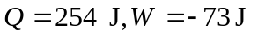(work is done on the system), and so 